Chapter 6 Sustainability
extra worksheet 4: Changing climate of Antarctica
Science Understanding Verbal/Linguistic
In 2009 it was reported by the U.S. Geological Survey that the ice sheets in the southern part of the Antarctic Peninsula (Figure 1) were disappearing and that the change in the amount of ice was significant. Since 1998 approximately 4000 square kilometres of ice has been lost from one area. This area of ice lost is about one and a half times the size of the Australian Capital Territory (ACT). This loss of ice is regarded as very strong evidence of the effects of global warming on the planet.
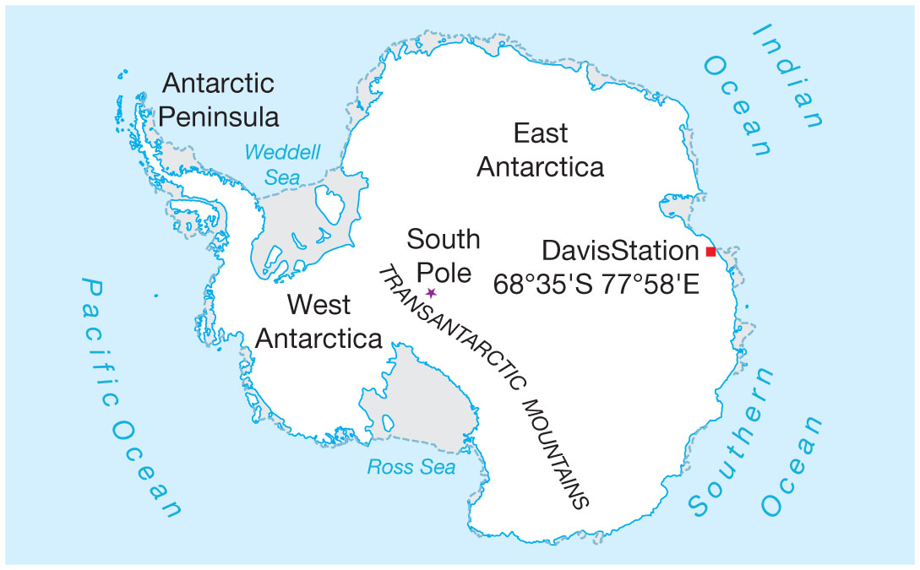
Figure 1
This map identifies the main areas of Antarctica.
However, in the same year it was reported by the Australian Antarctic Division that the ice is expanding in eastern Antarctica (see Figure 1) and parts of eastern Antarctica are becoming cooler. Ice core drilling in the ice off Australia's Davis Station in East Antarctica revealed that in 2008 the ice had a maximum thickness of 1.89 metres. The ice had not been this deep for 10 years. Since the 1950s, when continuous record began, the average thickness of the ice at Davis has been 1.67 metres.
Data collected do not provide any evidence of large scale melting of ice over most of Antarctica. The loss of ice in the west over the last 30 years has been more than offset by increases in the Ross Sea Region which is just one part of eastern Antarctica.
Over the past 30 years the area of sea ice around Antarctica has expanded. The changes in Antarctic sea ice are thought to be an outcome of modifications in the path followed by the Antarctic Circumpolar Current (see Figure 2). Warm moist air is directed towards Antarctic causing the ice to melt in the west and increased snow fall in the east.
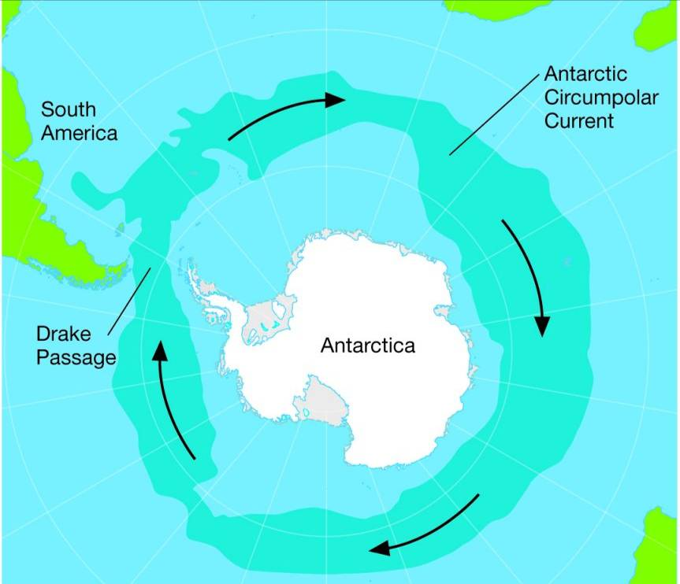
Figure 2
When the Antarctic Circumpolar Current moves closer to Antarctica it carries warm moist air towards the continent.

Effect on plants and animals
Flowering plants
Antarctica is home to only two species of flowering plant and both these grow on the Peninsula. The range (area over which they are found) and abundance (number of plants in an area) have both increased in the last few decades.
Krill
Krill are tiny shrimp-like crustaceans that are a very important food source for animals in the Antarctic. Krill numbers in Antarctica have declined by as much as 80% since the 1970s. Krill feed on algae that live just under the surface of sea ice. Where the amount of sea ice is decreasing, so too does suitable habitat for krill.
Krill feed the fish of Antarctica and are the main food source for baleen whales. In the years 1925 to 1975 baleen whales were hunted and their numbers decimated. Without krill it will be difficult for baleen whale numbers to recover to pre-hunting levels.
Penguins
With the shrinking sea ice in western Antarctica, the Adélie penguins (Pygoscelis adeliae) have declined in numbers over the last 20 to 25 years. In other parts of Antarctica the colonies are stable or increasing in numbers. Adélie penguins feed only on krill. The penguins nest on land and parent birds go out to the sea ice to find food for their chicks. A reduction in the amount of sea ice not only reduces the Adélie penguins’ food supply, it also increases the distance the parent birds have to travel to find food.
Some penguins are benefiting from the changes taking place in Antarctica. Gentoo penguins (Pygoscelis papua) (Figure 1a) are nesting on the Antarctic Peninsula. Studies of the bones and other remains found in penguin colonies indicate that Gentoo penguins did not nest in this area before 1950. These penguins feed on fish and squid as well as krill.
Chinstrap penguins (Pygoscelis antarctica) (Figure 1b) are also benefiting from the changes. Where Adélie penguins are abandoning their nesting sites Chinstrap penguins are taking their place. There is no evidence of Chinstap penguins on the Antarctic Peninsula until about 50 years ago when the average temperatures started to rise. Chinstrap penguins eat a wider variety of food than the Adélie penguins and they also prefer open water.
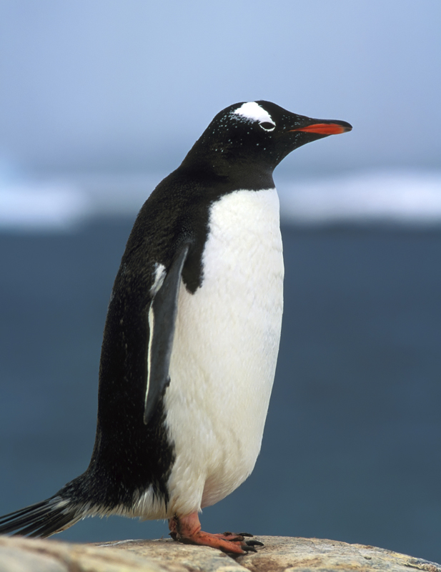 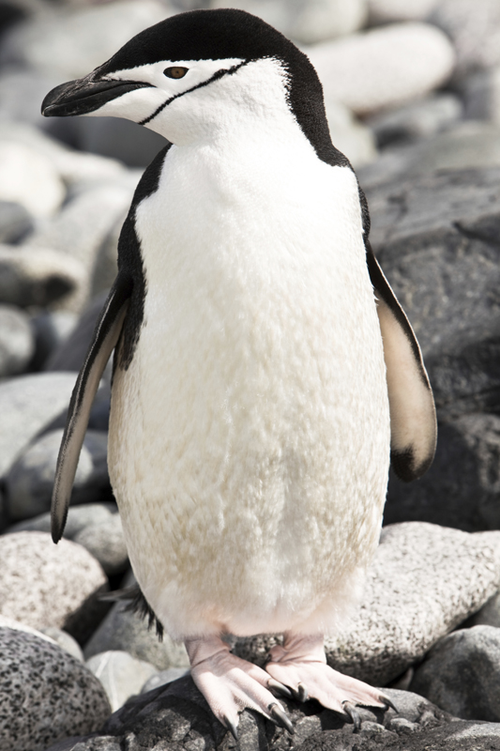
a b
Figure 3
Gentoo (a) and Chinstrap (b) penguins both benefit from the warmer conditions in Antarctica.
The number of Emperor penguins (Aptenodytes forsteri) in Antarctica is declining. Krill is the main food source for Emperor penguins. Warmer weather means less krill. In the 1970s there was an unusually warm spell in the Antarctic and in this time Emperor penguin numbers declined. In the 1980s cooler conditions meant that there was more sea ice and therefore more food. However, the penguins hatch fewer eggs when there is extensive sea ice because the female has to travel far to get food, so the colonies were not able to recover their numbers.

Questions
1 a Compare the changes that are occurring in the western and eastern parts of Antarctica.
____________________________________________________________________________________________________________________________________________________________________________________________________________________________________________
b Identify the possible cause of these events.
____________________________________________________________________________________________________________________________________________________________________________________________________________________________________________
2 Explain why the lack of sea ice affects the abundance of krill.
_________________________________________________________________________________________________________________________________________________________________________________
3 Identify the organisms that.
a are adversely affected by the reduced amount of krill.
______________________________________________________________________________________________________________________
b have benefited from global warming.
______________________________________________________________________________________________________________________
4 Assess whether all colonies of Adélie penguins in Antarctica are affected in the same way by the changes in climate.
_______________________________________________________________________________________________________________________________________________________________________________________________________________________________________________________________________________________________________
5 Deduce why Chinstrap and Gentoo penguins have been able to take over the habitat of Adélie penguins in the Antarctic Peninsula.
_______________________________________________________________________________________________________________________________________________________________________________________________________________________________________________________________________________________________________
6 Use the information presented here to construct a consequence wheel for global warming in Antarctic. (See page 200 of the student book for help with constructing a consequence wheel.)

